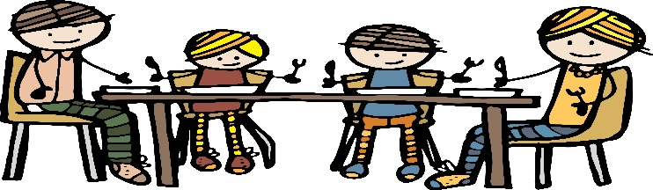

**Class 3 Newsletter**

**Term 2 2016**

What we are learning

Our topic for this term is ‘Back in Time for Dinner’. Just like the BBC2 programme we will embark on an extraordinary time-travelling adventure to discover how our experience of food has changed over the last 100 years. The children will have the opportunity to cook and sample a range of traditional dishes from the past as well as finding out where our food has come from and how shopping habits have changed.

In Literacy we will begin by learning the story ‘The Disgusting Sandwich’ by Gareth Edwards. The children will write their own stories about a disgusting food, based on the structure of the original story. The food theme will continue through our non-fiction writing, which will focus on recipes, while in poetry we will be exploring classic poems.

This term in Maths we will be learning various methods of calculating addition and subtraction problems. Towards the end of the term the children will explore money and solve real-life problems, including paying for items and giving change.

Our learning in Science will focus on ‘Animals, Including Humans’. The children will learn about how humans and other animals are born, grow and change, and what we need to survive and be healthy.

In Design and Technology the children will be investigating the technique of weaving. They will design and make their own loom for a dinner placemat before weaving materials to complete their work.

The RE unit this term is ‘Belonging’. We will be finding out what this means within Christianity and other religions such as Islam and Judaism.

Dates for this term

28th November – Christmas Art Week

7th December – Christmas Fayre

14th December – KS1 Nativity

16th December – End of Term 2:30pm

More news

As part of our topic, we will be giving children the opportunity to bring home cookery bags. In each bag is a recipe card and the equipment needed to cook a dish for your family. Cooking is a fantastic activity to do with your children; they can learn and practice a whole range of skills, plus it gives them a better understanding of food and where it all comes from. The smallest of hands can be surprisingly good in the kitchen, so why not get those sleeves rolled up for some good cooking fun with your children.

 Ho! Ho! Ho! Yes, Christmas is coming, which can only mean one thing – the Key Stage 1 nativity! As always, we appreciate all your support with this, especially costumes. You should receive a letter very soon with regards to costumes. While children in Year 3 will not be performing in the nativity, they will be involved in creating the scenery and props needed for the performance. They will however, have the opportunity to shine in the Key Stage 2 performance in the Summer term

Zumba club continues on Fridays after school until 4pm. This is open to all children in Class 3 so if your child would like to take part please let Mrs Adamson know.

**Thank you for your continued support.**

Reminders

It’s great to see so many children completing their homework each week. They certainly enjoy seeing the results of their hard work when they complete their spelling and times-table tests! Please continue to encourage your children to complete their homework. We now have special bronze, silver and gold ‘times table’ badges, which the children will receive in our Achievers Assembly once they are confident in recalling their time tables.

Please remember that PE Kits are needed in school **everyday.** Without the right kit it is very hard for your children to enjoy the full curriculum within school. We now have Fundamental Skills on a Tuesday and Gymnastics on a Thursday.