St Mary's Church of England Primary School & Nursery
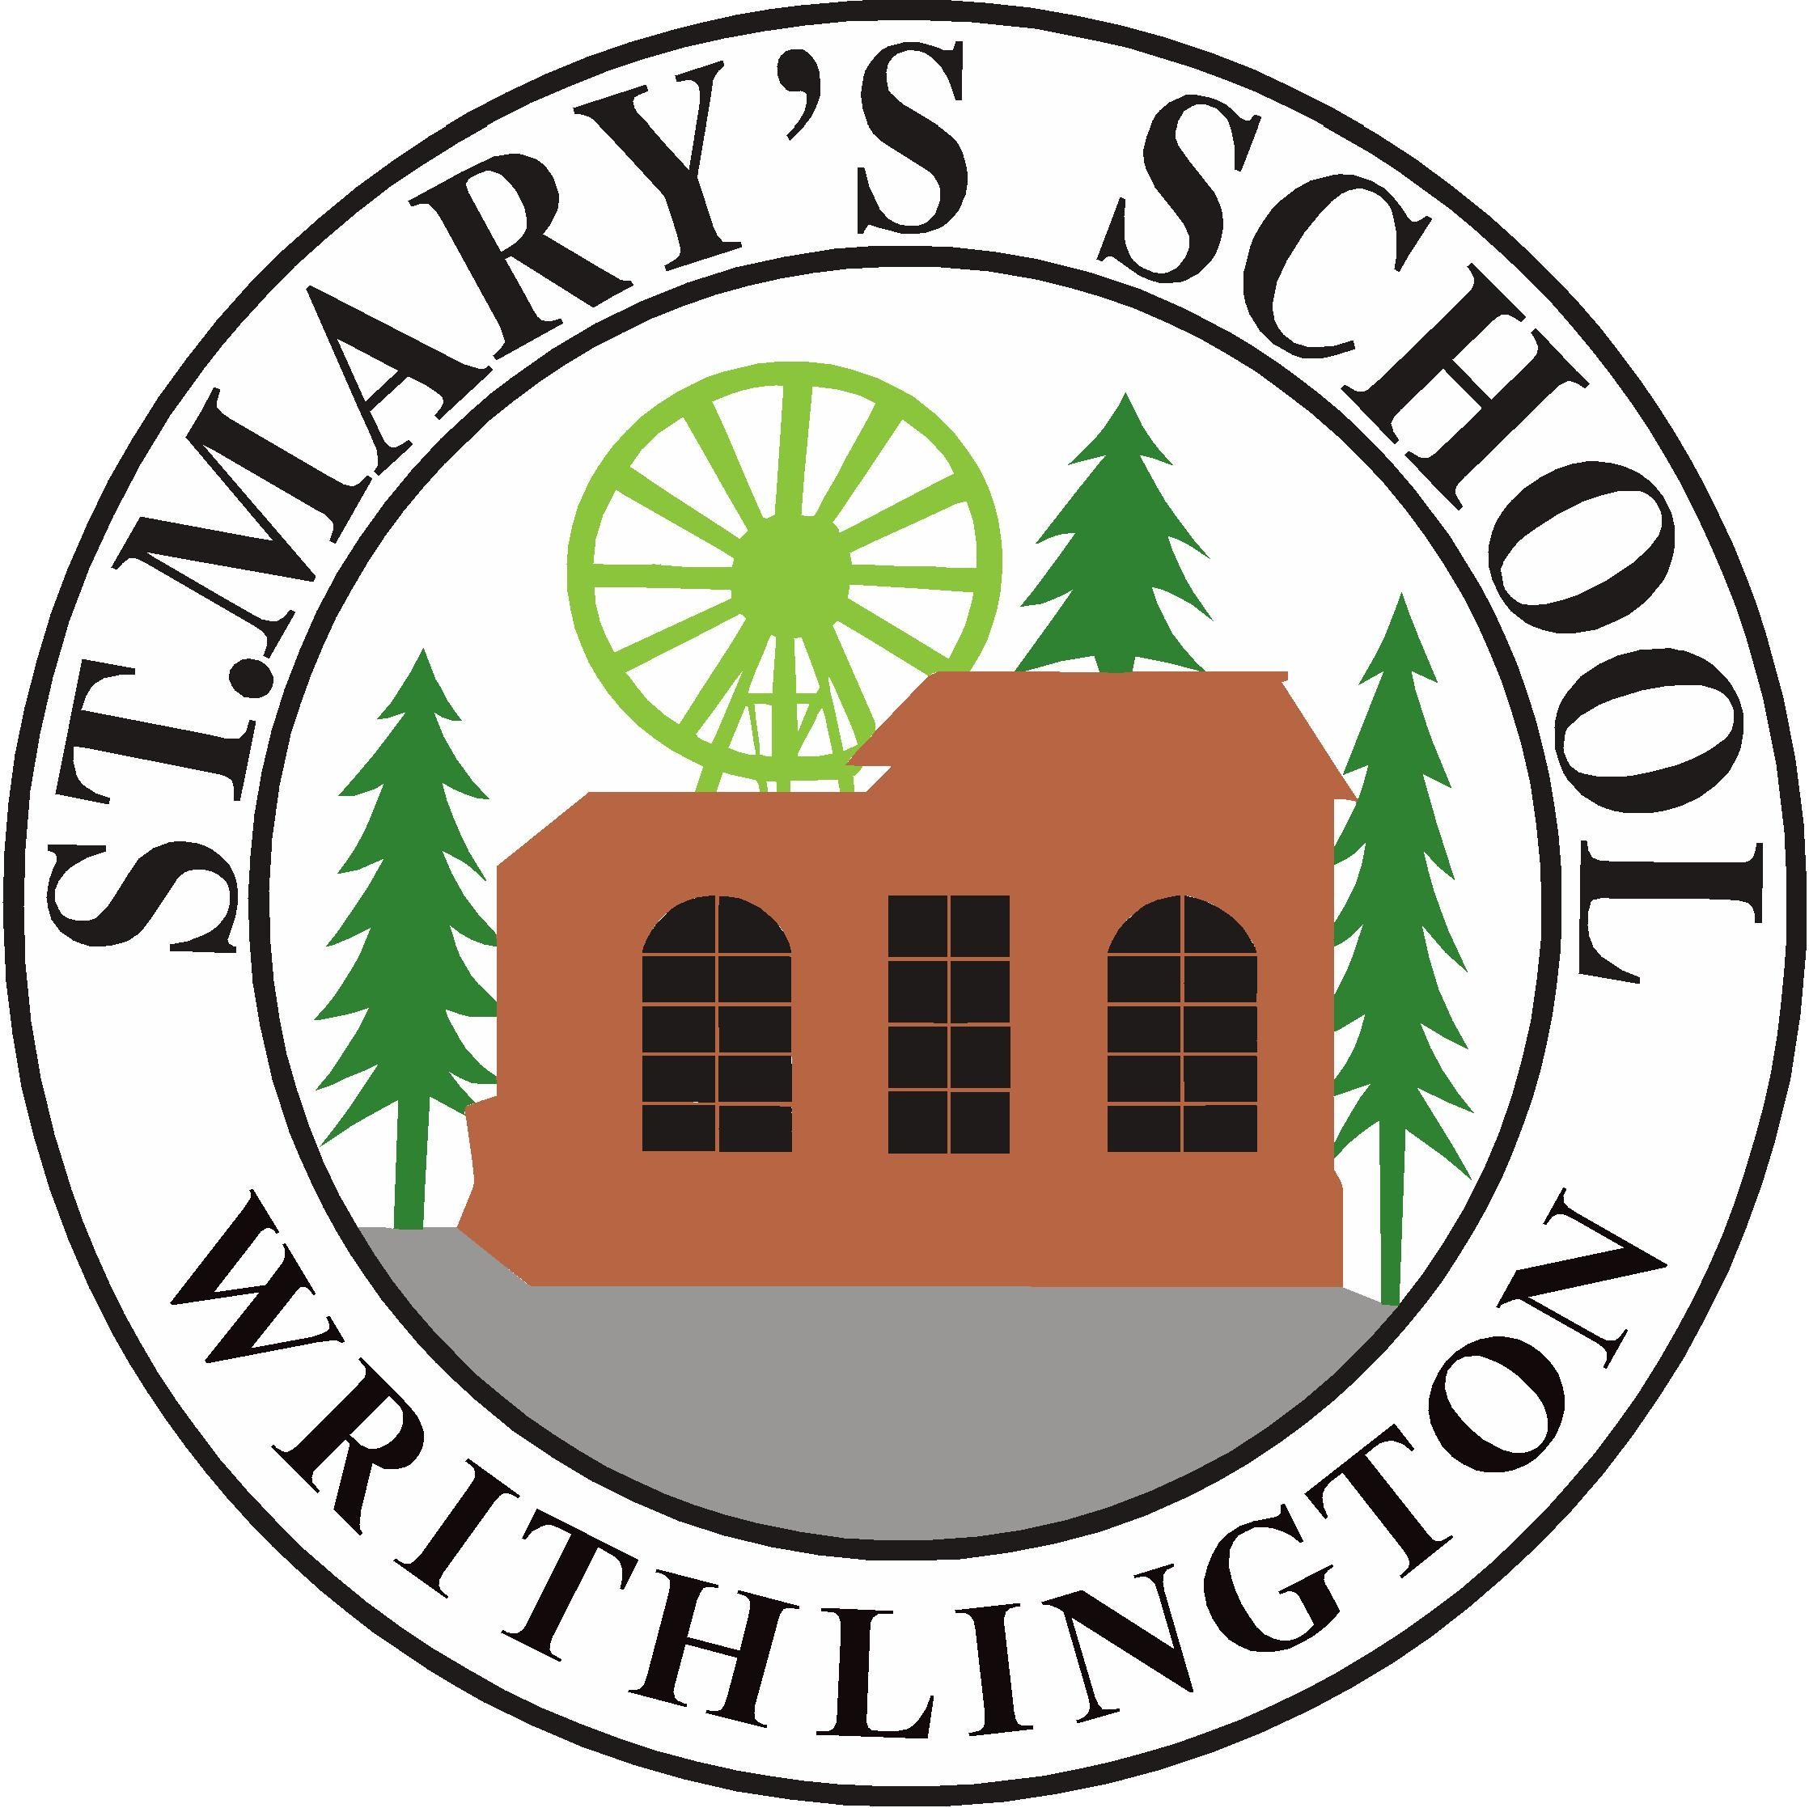
Old Road, Writhlington, Radstock, BA3 3NG
Telephone 01761 434548
email: stmaryswrithlington_pri@bathnes.gov.uk
website: www.stmaryswrithlington.co.uk

Head Teacher : Cathie Lampert
Deputy Head Teacher: Beth Hamblin

Friday 20th March, 2020

Dear Parents and Carers,

The school will be open from Monday 23rd March (until further notice) for your child/children as they fall into one of the following groups:
- Vulnerable – EHCP, CP, Carer
- You are a critical worker – Nurses, Doctors, Police etc.

You will have already notified the school of which days you will be bringing your child/children in and we have now made provision for this.

The timings of the school day will run as usual, opening our doors at 8:45am and closing at 3:15pm.

We will be running Class 1, but we ask you to come to the front entrance of the school. Parents/Carers will not be able to come into the school/classroom and children will be expected to wash their hands before leaving home and as soon as they enter the classroom.

Children are to wear clean, practical clothes from home, and they are expected to wear fresh clean clothes every day that they attend our school.

There will be a Teacher and Teaching Assistant running the class due to very small numbers, and the staff members will vary throughout the week. This could potentially change if we experience staff shortages. The school will endeavour to remain open for as long as we can, or until the Government advises otherwise.

There will be no milk or fruit being delivered to school, so please provide a healthy snack from home each day that your child attends. If you are entitled to a Free School Meal and you have arranged for this to be ordered from Writhlington School, you will need to go and collect it and bring it to school with your child. If you have not arranged to collect a Free School Meal or you are not entitled, please ensure you pack and bring a healthy lunch to school.

If your child needs medication (such as inhalers) please ensure they are in school. You also need to make sure that we have up-to-date contact information, as it is crucial we are able to contact you whilst your child/children are in our care.

It is essential that you follow the Government’s guidelines. If your child becomes unwell (with a cough and or fever), or if indeed anyone in your household does, you must stay at home and practice self-isolation for 14 days. Seek medical advice online, or call 111 for medical advice.

Please be reassured that we will continue with routines in school to support our most vulnerable children, with exercise breaks, outdoor play, stories, and some lovely practical activities. We will expect the high level of behavioural standards as we always do at St Mary’s School. The children’s safety and happiness is of the utmost importance to us and we look forward to supporting your children and our key worker parents in bringing things back to ‘normal’ as quickly as possible.

We thank you for your continued support.

Cathie Lampert

