
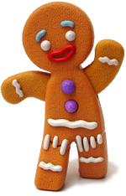
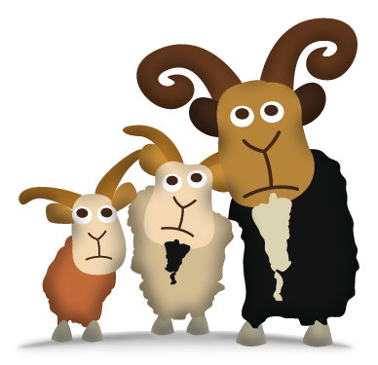

St Mary’s Primary School Writhlington

We hope you had a lovely Christmas! A belated Happy New Year to you all. Welcome to Spring Term 1. We have a fun packed term to enjoy, which is already flying by!

Topic
The topic this term is Fairytales, as we have a whole school topic based around books.

Dates for your diary
Thursday 19th Jan 3.15-4pm-Reading Café in Little Oaks (see attached letter)
Friday 20th Jan Teddy Bears Picnic
Wednesday 8th February 5.30-6.30pm Bedtime Story (More information to come)

PE Kits required on Wednesday. This term we are lucky enough to have a specialist Dance teacher, Libby working with us!

Nunney Castle Trip
We are waiting to hear from the coach company with our new trip date-hopefully before the end of this term!

Phonics
In phonics this term, we are continuing to learn new Phonics Sounds. We have attached the link to the parents section of our Phonics programme.
We will send home a copy of all the sounds we are learning in the children’s sound books. It is our aim for the children to develop a quick recall of each sound.
https://www.littlewandlelettersandsounds.org.uk/resources/for-parents/
As the children become more confident identifying these sounds, they will be able to read more words and sentences that contain words made up of the sound we have learnt, alongside the ‘Tricky Words’ that the children are practising.
Please continue to help your child by practising the pronunciation and formation of these sounds at home too! (See attached sheet) We are also learning many new sounds called ‘digraphs’ (two letters that make one sound, e.g. ch in chip) and ‘trigraphs’ (Three letters that make up one sound, e.g. igh in might. These can also be a challenge so please continue to practise in the sound books!
Literacy
This term, across the school is book term…
In Literacy, we are learning all about story language and sharing a range of fairytale stories. We are going to be studying different characters in stories and creating ‘speech bubbles’ for them. We will begin to create ‘story maps’ which will help us to sequence and understand how stories are structured. We will become familiar with the language in these stories- great for helping children to develop a real enthusiasm for the stories and to be able to retell them themselves. Next week, we will be learning all about Goldilocks (who is very naughty!) and the children will be writing and sending an invitation home to invite their teddy bear into school for the day for a special event (please send a reply from their teddy as a magical surprise!). More information to follow on Monday.
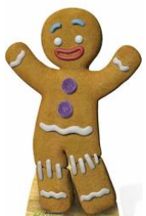

Run, run, as fast as you can, you can’t catch me- I’m the Gingerbread man!

Mathematics
Our Key Instant Recall Fact (KIRF) for this term is: ‘To be able to partition numbers to 5 into two groups’. There is an information sheet attached to this newsletter to help with learning at home. For those pupils that have already mastered this skill, we will be developing further, by utilising these skills in a range of contexts. Already this term, we have watched some episodes of Numberblocks (which can be found on the Cbeebies website), to support with learning. We will continue to consolidate the skill of subitising (instantly recognising amounts without counting). Little Oaks have been using numicon to support with this skill, and to understand which pairs of numbers total 5. We played a great game with beanbags this week – it was great fun! We are learning about weight and capacity and linking this to planting in different sized pots – let’s hope something grows! After lots of focus on numbers 0-5, we will spend the rest of the term looking at numbers 6, 7 and 8. We work 1:1 each week with your child on their learning steps and the support at home really does help, thank you for all of your efforts!

Foundation Subjects
We have another jam-packed term, full of fun stuff to help us to learn so many skills! We have Three Little Pig puppet shows to create and gingerbread men to bake!
We will also be listening to and appraising a range of music, and learning some new songs (now the Nativity ones are out of our heads!).

Reading
Please read the phonic books and reading for pleasure books with your child as often as you can. Keep using the sound books to practise the new sounds!

