St Mary’s Primary School Writhlington

Welcome back to Autumn Term 1 - we hope had a lovely summer break and we are looking forward to getting to know you all this year.

Topic
The topic for Autumn Term 1 is…

All About Me.



The children have been so happy the last few days – we have had smiles all round! We will be spending this term getting to know each other, and our new classroom.

Reading
Yesterday your child brought home their first ‘Reading for Pleasure’ book. These ‘Story Book’ type texts are for you to enjoy and read to your child, perhaps snuggled up together on the sofa, or as a bedtime story?
The children will also soon be coming home with a ‘Phonics’ based reading book. This is for them to read as independently as they can, with your support. The Phonics based reading book is linked to our Phonics teaching in class and to our school’s chosen Phonics Program-
For parents | Letters and Sounds (littlewandlelettersandsounds.org.uk)
Initially, the books will be without words Sharing wordless books with your child provides a great opportunity for literacy-rich conversations. Each ‘reader’ listens and speaks, and creates their own story in their own words. Please commit to sharing a book with your child as often as you can. Reading books to children stimulates their imagination and expands their understanding of the world. It also helps develop language and listening skills.10 minutes a day will really make a difference to your child’s progress in reading.

You are all invited to a meeting to talk about Phonics, Reading and Homework in Little Oaks Classroom, on Wednesday 11th September at 3.15-3.30

PE Kits required on Wednesdays this term please! We will be outside wherever possible so proper P.E. daps or trainers are a must! Please do label all P.E. kit.
Do send your child to school wearing their PE kits on Wednesdays.

Please could you send your child into school next week with a photo of themselves as a baby (names on the back please) and also a photo of themselves with their family? We will be using them in class and they will be returned once we have finished with them.

Welcome to Little Oaks!
Staffing
Monday: Miss Hamblin (Class Teacher)
Tuesday/Wednesday/Thursday/: Mrs Martin (Class Teacher)
Friday: Mrs Gallimore (before lunch) Abbie Teal (after lunch)
This year, we have a small class size of just 11 children, which means adult: child ratios are very high, and all pupils will benefit from being supported closely by skilled adults. We are very impressed with the way the children are coming into class in the mornings by themselves and settling quickly. We make sure that their safety and happiness is our top priority and the children have been very willing to begin to understand and follow our class promises (rules), which are:
Be kind - Listen to the teacher and each other - Help each other to learn – Be the best you can be - Look after our toys, our classroom and all living things - Have fun!

Literacy
We will begin our topic by sharing the story All About Me. Each week, our Literacy focus is planned around a carefully selected quality text, Fiction or Non-Fiction. The children get to know these books and stories really well and often can be heard retelling them to each other! We always encourage the children to speak to each other and the teaching staff in full sentences and we model correct grammar and explain tricky vocabulary to support the children’s own language development. You can support your child by talking about the pictures in their reading book to enable the children to understand what the story will be about. This will increase their confidence to ‘have a go’ particularly at this early stage of reading.
Other Key Texts this term will include:
The First Rainbow
The Colour Monster
Harry and the Dinosaurs go to School
Anna Hibiscus Song-
All Join in
Polar Bear, Polar Bear

Mathematics
At St Mary’s we use the ‘White Rose Maths’ program.

Parent resources | Maths workbooks | White Rose Education
In maths sessions this term, we will spend time getting to know numbers and becoming more secure with counting. This includes matching and sorting shapes and symbols, and making and describing repeating patterns. We will also learn to compare quantities, and begin to use the terms ‘more’, ‘less’, ‘fewer’, and ‘equal’. Later in the term, we will be learning about patterns (fruit kebabs often make an appearance here!) and we will begin to look at numerals. In the last few weeks, we will be learning all about ‘subitising’, which is the skill of being able to instantly recognise quantities, such as when we roll a dice (we don’t count the dots, we just ‘know’ the quantity!). In addition-once a week, your child participates in an activity 1:1 with the teacher called a ‘Learning Step’. This focuses on your child’s individual next step in their maths learning. We communicate these in the reading record – so please practise these as often as you can at home too please!

All Other Learning
In music sessions this term, children will be learning to listen and appraise a variety of songs. We will also be learning some familiar songs, such as 1, 2, 3, 4, 5, 5 Little Ducks, This Old Man, Things for Fingers and The Name Song. That’s not to mention all the nursery rhymes we learn each week as well!
In P.E. this term, the children will be introduced to PE and structured movement through the topic of 'everyday life'. They will spend time learning basic principles of a PE lesson such as safely using space, stopping safely, using and sharing equipment and working individually, with a partner and within a small group. Our Personal, Social and Emotional Development (PSED) learning is based upon the Jigsaw PSHE program.
Our unit this term is called, “Being Me, in My World”. The children will learn through sessions such as: Help others to feel welcome, to think about everyone’s right to learn and working well with others.
Our R.E. topic this term is called: ‘Special People’. The children will be talking about their family and people who are special to them. They will be talking about what they enjoy, what they are good at and places they like to be, also, learning about a Christian Story and talking about it (Noah’s Ark).

Dates to Remember
9th September -Little Oaks in-Full Time! 8.40-3.15
10th September-School Photos
11th September – 3.15-330pm Little Oaks PARENTS phonics and reading meeting
20th September-British Values Day
2nd October – Little Oaks outing to Bath Children’s Literature Festival- More details to follow (9.30-11.30)
8th /9th October - Parents Evenings
End of term 1 - Friday 25th October

‘
We will soon have ‘Tapestry’ up and running-which is a two-way digital learning platform for us to share information about your child’s progress. Every two terms we will upload a ‘Learning Summary’ to Tapestry, which will include photos and a written report on what your child has been up to, the progress they have made, and any area they may need additional support with – much like you received in Nursery. Please feel free to upload any photos and comments at any time, we really value all of your contributions!

We are also sending home your bar codes to scan to activate your child’s Class Dojo account. This is our main messaging platform, we will share any class photos and news here so it is important that you do sign up.

Children in Little Oaks spend lots of time learning outside, so please ensure they have a pair of wellies (labelled!) that can be brought and left at school, and a waterproof coat. We go out in almost all-weather conditions so we need to be extra prepared as we head towards the winter months.

And remember, if you have any questions about your child’s time in Little Oaks please feel welcome to use Class Dojo, email or simply come and talk to us.
The Little Oaks team ☺
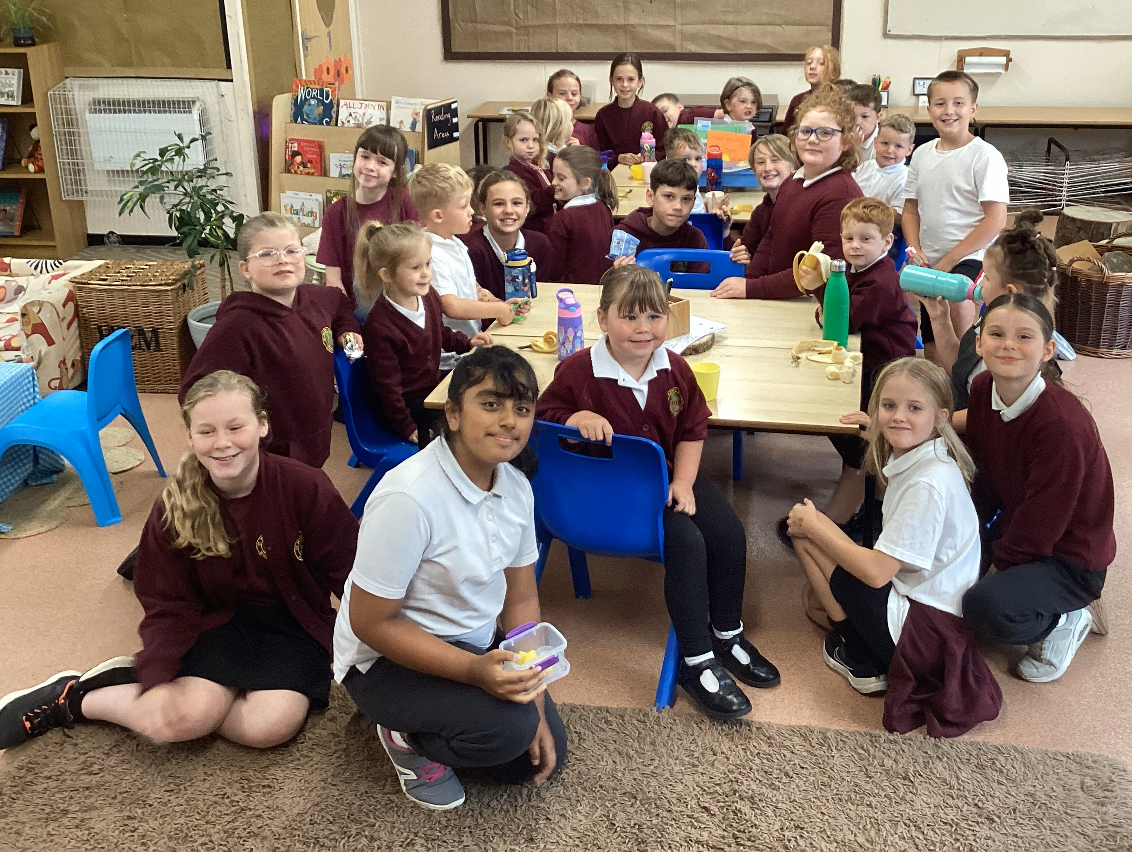
The children all have a buddy or buddies from Year 6. This week the buddies were supporting the children to settle in at lunchtime and playtimes.

