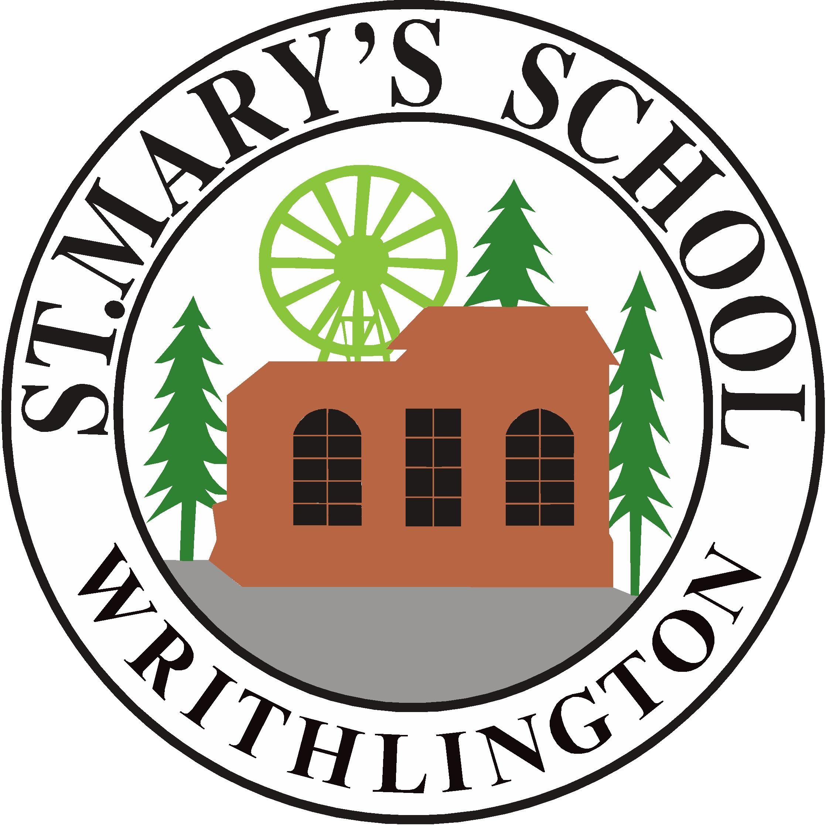
St Mary's Church of England Primary School & Nursery

Old Road, Writhlington, Radstock, BA3 3NG
Telephone 01761 434548
email: stmaryswrithlington_pri@bathnes.gov.uk
website: www.stmaryswrithlington.co.uk

Head Teacher : Cathie Lampert
Deputy Head Teacher: Beth Hamblin

4th June, 2020
Dear Parents,

We are pleased to have been able to open to more pupils from Wednesday 3rd June. It has been lovely to see the children and to begin a new ‘normal’. Particularly impressive, has been their understanding of the new school rules and behaviour policy; they have abided by government social distancing rules and been washing their hands very regularly, being careful to look after themselves and others.

Notice to Return
We are now mindful that we have our groups (apart from Reception and older Nursery children) back in school and would ask for those children in Nursery (N2), Reception, Year 1 and Year 6 or those with key worker parents provide us with a minimum of 1 weeks notice from the Monday. For example, if you advise us on Wednesday the 10th June your child would be able to start on the 22nd June.
As I am sure you can appreciate we have many families with many different requirements at the moment and we are trying our upmost to accommodate you all. Having time to plan and arrange these groups is very much needed.
Children Social Distancing Outside School
A reminder that the safe return to school for pupils and staff, is based on the ‘Bubble System’; children taught in small groups. Should children be mixing with other children, outside these groups or their households, the risk of catching COVID-19 increases for all the children in the bubble and staff.
Children should NOT be playing with other children outside school. Bringing children into school who are mixing with others would make the school less safe for all. We are trusting you to keep the children (and us) in school safe and to do the right thing.
School Dinners – for children in school
From 15th June we are hoping to resume school dinners for children in school. At this time, for the last 5 weeks of term, we would ask that children either opt into having a school dinner or opt out. Writhlington catering, who provide our school dinners, are offering a different meal each day based on a picnic-style meal.

Monday
Tomato and Herb Pasta Pot
Homemade Cookie
Piece of Fruit
Bag of Healthy Crisps
Carton of Fruit Juice

Tuesday
Ham /Cheese /Egg Mayo Sandwich
Piece of homemade cake
Fruit salad
Bag of Healthy Crisps
Carton of Fruit Drink

Wednesday
Jumbo Sausage roll
Homemade biscuits
Piece of fruit
Bag of Healthy crisp or popcorn
Carton of fruit drink or water

Thursday
Cheese and Ham Ploughmans
Flapjack
Fruit jelly pot
Bag of Healthy crips
Carton of Fruit drink

Friday
Chicken mayo wrap
Piece of Fruit
Bag of Healthy Crisps
Homemade chocolate cake
Carton of fruit drink
We will need to order these meals with the kitchen by lunchtime on Friday 12th June. Any orders received after this date will not be processed. Please indicate below should you wish your child to receive a school dinner. Please indicate any dietry requirements. A vegetarian option will be available.
Free School Meals
The Edenred Vouchers will be issued for those pupils in receipt of Free School Meals for the remainder of the term.
Kindest Regards,
Ms Lampert

School Dinnner Order Form
I would like a packed lunch ordered for my son/daughter …………………………………………………………. from Monday 15th June until the end of term 6 (July 17th).
Any dietry requirements: ……………………………………………………………………………………………………………..
………. My child is in receipt of Free School Meals
……… My child is in Reception, Year 1 and Year 2 (universal Free School Meals) and in is in school.
………. My child would like a school packed lunch at £2.60 per meal – I enclose payment.
(Please tick)

