St Mary’s C of E Primary School, Writhlington
‘Inspiring Learning Together’
Scheme of Work + Knowlegde Organiser
Picture or illustration:
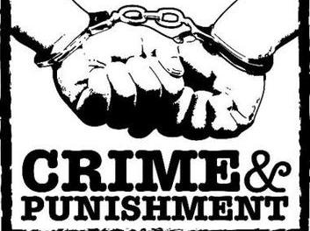
National Curriculum:
Study an aspect or theme in British history that extends pupils chronological knowledge beyond 1066.
Wider Curriculum:
To a local police station.
Key Vocabulary:
Capital punishment: killing of the criminal
Corporal punishment: physically hurting the criminal
Court: a group of people, including a judge, who bring people to justice
Crime: an activity that breaks the law
Criminal: someone who commits a crime
Heresy: having religious beliefs that were different to that of the official religion of the country
Jury: a group of people who decide/make a decision in court
Justice: fair treatment
Law: rules made by the people in charge of a country or place
Lawyer: a person who studies the law
Prejudice: having an opinion about something which is not based on facts and is biased
Retribution: making a criminal suffer for the crime committed
Theft: stealing
Treason: a crime against the king or government
Wergild: money that must be paid for your crime.

The Learning Journey:
Do I understand that crime and punishment has changed from the Romans to the 21st century?
- Children will be introduced to the time periods we are going to be covering in this topic as well as key vocabulary.
Can I describe crime and punishment in the Roman period?
- Children understand that Roman’s had a very detailed legal process, yet many crimes went unpunished.
Can I describe punishment in the Anglo-Saxon and Viking period?
- Children know that most crimes were dealt with by compensation (weregild).
Can I describe crime and punishment in the medieval and Tudor periods?
- Exploring crime and punishment from 1066 to 1603. Exploring specific punishment techniques.
Can I describe crime and punishment in the early modern period?
- Children will explore the plot to blow up the houses of parliament and civil war due to religion, with many crimes relating to religion at the time such as witchcraft.
Can I describe crime and punishment in the Victorian period?
- The biggest change was the creation of the police force.
Can I compare and contract all I have learnt this term?
- Children to create a timeline demonstrating their understanding of the changes to crime and punishment throughout history.
Off with their Heads!

