PURPLE MASH COMPUTING SCHEME OF WORK - KNOWLEDGE ORGANISER
Unit: 5.4 – Databases
Key Learning
Key Vocabulary
Avatar – An icon or figure representing a person in a video game, Internet forum, etc.
Binary tree (branching database) – A way to sort information by dividing the information into groups based upon questions with yes or no answers.
Charts – Representing information in a pictorial form.
Collaborative – Produced by, or involving, two or more parties working together.
Data –Facts and statistics collected together for information.
Database – A set of data that can be held in a computer in a format that can be searched and sorted for information.
Find - Search for information in a database.
Record – A collection of data about one item entered into a database.
Sort, Group and Arrange – Different ways to sort information in a database to it is easy to read, understand and interpret.
Statistics and reports – To produce information about data in a database.
Table –Sorting information into rows and columns.
To learn how to search for information in a database.
To contribute to a class database.
To create a database around a chosen topic.

Key Resources
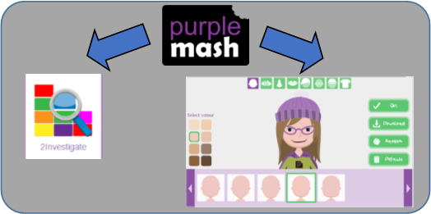

PURPLE MASH COMPUTING SCHEME OF WORK - KNOWLEDGE ORGANISER
Unit: 5.4 – Databases
Key Questions
Key Images
What is a database?
Avatar creator | 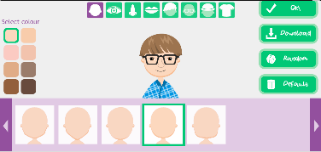
Open, save or share a file.
Design a new database
Add a record to the database
Find information in the database
Sort, group and arrange information.
Statistics and reports
Represent the information as a chart

A collection of data organised in such a way that it can be searched, and information found easily. Database usually refers to data stored on computers.
In what ways can I sort information in a database?
A database can hold lots of information so it is essential that information can be effectively investigated. In 2Investigate, data can be searched and sorted in a variety of ways. It can also be presented pictorially.
Why is the collaborative feature important?

Making a database collaborative allows lots of people to enter information into the database at the same time. This is a lot quicker than one person entering the data by themselves.

