Starting in Reception – Butterflies

St Mary’s Church of England Primary School and Nursery, Writhlington.

- Be the best you can be -

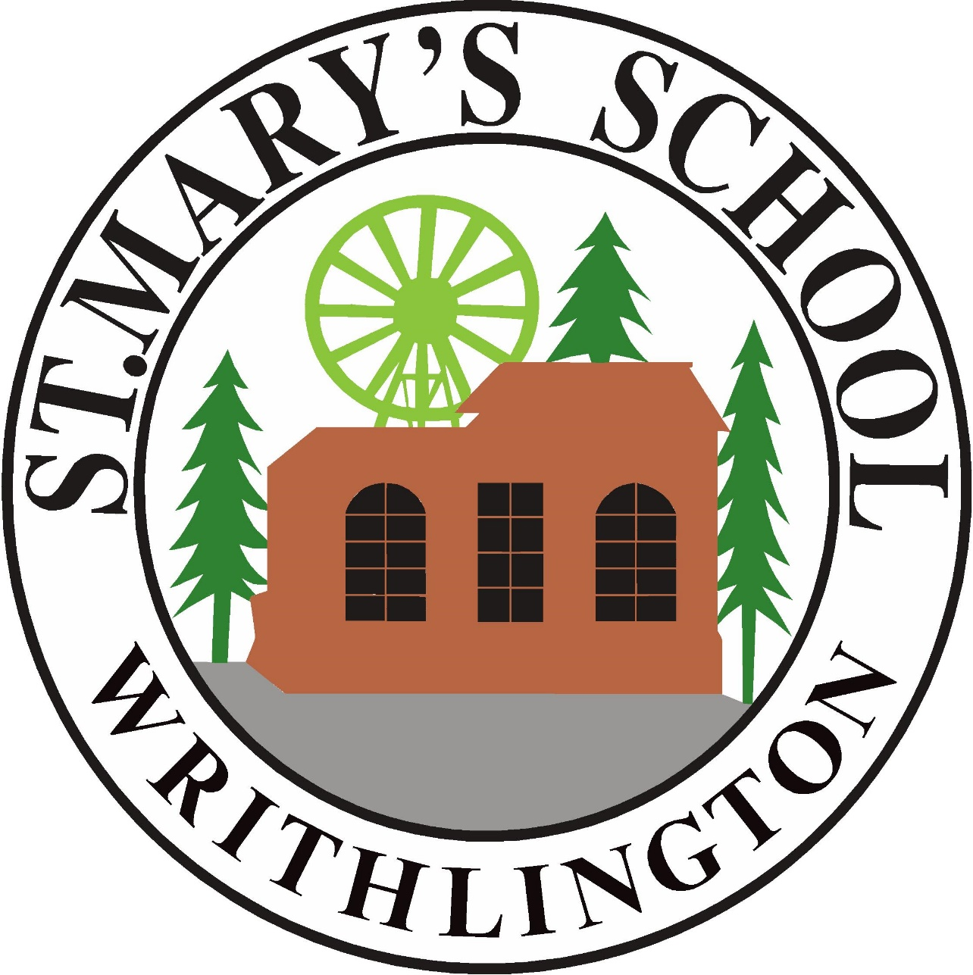

Welcome!

A very warm welcome to Reception at St Mary’s Church of England Primary School and Nursery! This is an exciting time for you and your child and we aim to make joining our school community (children and parents/carers included) an enjoyable and special time. We hope this booklet will answer some of the questions most frequently asked by parents/carers. If you would like to know anything that hasn’t been covered here, please feel free to e-mail us at:
office@stmaryswrithlington.co.uk or contact the school office on 01761 434548.

Class Teacher:
Miss Norris
The pupils in the reception class are also supported by at least one Teaching Assistant.

We believe that the teacher and parent/carer relationship is essential to your child’s learning journey. Throughout the academic year we will be inviting you in to see what wonderful learning we get up to in school, so please look out for invitations during the reception year.

We aim to make our classroom learning environment a loving, fun, safe and inspiring place to be.

Daily Routines

8:40am – Doors Open for Reception Pupils
8:45am - Registration
10:15am – Rolling Snack/Play time
12:00pm – Lunchtime
1:00pm – Registration
2:45pm – Collective Worship/Assembly
3:15pm – Home Time

We expect all children to enter the building independently, parents and carers are not permitted to enter. Boxes for book bags and resources, and a trolley for lunchboxes and drinks will be outside to facilitate this. We encourage parents/carers to keep the ramp and steps clear. The class teacher and teaching assistant will welcome children into the cloakroom, and they start their day by completing a short Early Morning Activity (EMA), and independent, self-registration.

Morning activities include: Phonics, Literacy and Mathematics. Afternoons are topic-based, although all the areas of learning overlap throughout the day. We also run outdoor learning sessions every week, in all weather conditions (as appropriate!).

During ‘rolling snack’ in the morning and afternoon, the children have milk or water and a healthy snack (usually fruit or vegetables, which is provided by the school.)

After lunch, the children also participate in a short physical activity.

A range of child-initiated, play-based activities are available throughout the day covering the different areas of learning to consolidate and extend skills and knowledge.

Children have use of both the indoor and outdoor classroom, and where possible, other areas of our beautiful school grounds.

We are a Church of England school and teach Christian values as part of our learning ethos.

St Mary's School Uniform

All children are expected to wear school uniform. It helps to give the children a sense of school identity and being part of a team, and allows everyone to be equal.

Our uniform has been deliberately chosen to be easily available and cost effective. School sweatshirts, polo shirts, PE kit and bags can be purchased from our school provider: Gooddies, (https://gooddies.co.uk). All other items are easily available from stores locally.

Our school uniform is:
- School sweatshirt or cardigan with school logo
- Grey/black trousers/skirt/pinafore
- White blouse/shirt or polo shirt
- Lighter weight dress for the summer
- Black school shoes

Our PE Kit uniform is:
- Plain burgundy t-shirt (no football kits please)
- Black shorts
- Daps or trainers (non-marking soles)
- PE Hoodie (optional) - can be purchased through Gooddies
For outdoor games, children may wear a tracksuit in cold weather. This must be plain black.

All children need a pair of wellies in school at all times for lunch time play/outdoor learning sessions

We do NOT allow:
- The wearing of jeans
- Jewellery (dangling earrings, rings etc.) except studs
- Make-up in any form, e.g. nail varnish.

PLEASE ensure all clothing, including P.E. kit and property, is clearly marked – thank you!

Our Principles

In line with the Statutory Framework for the Early Years Foundation Stage, we follow the following principles…

- Every child is a unique child, who is constantly learning and can be resilient, capable, confident and self-assured.

- Children learn to be strong and independent through positive relationships.

- Children learn and develop well in enabling environments with teaching and support from adults, who respond to their individual interests and needs and help them to build their learning over time. Children benefit from a strong partnership between practitioners and parents and/or carers.

- Importance of learning and development. Children develop and learn at different rates.

These principles are part of the foundations of our practice.

Characteristics of Effective Teaching and Learning

- Playing and exploring: children investigate and experience things, and ‘have a go’.

- Active learning: children concentrate and keep on trying if they encounter difficulties, and enjoy achievements.

- Creating and thinking critically: children have and develop their own ideas, make links between ideas, and develop strategies for doing things.

The Curriculum

The Government updated the EYFS Statutory Framework in July 2025.

Reception children are working within the Early Years Foundation Stage (EYFS), before they start the National Curriculum in Year 1. Our belief, that young children learn best through play-based activities, is based upon evidence-based research. These include focused activities with an adult (adult-directed), activities which the children choose themselves (child-initiated), and activities created by an adult that children engage with through our continuous provision (adult-framed). Children do a mixture of activities on a daily basis. They also spend a lot of time outdoors!

In line with the statutory framework, we have worked hard to develop a curriculum that seeks to ensure:
- Every child makes good progress
- A secure foundation in learning and development of each child
- Partnership with teachers and parents/carers
- Equality of opportunity and anti-discriminatory practice, ensuring that every child is included and supported

The Early Years Foundation Stage is made up of seven areas of Learning and Development. All areas of Learning and Development are connected to one another. The areas of learning and development are underpinned by the principles of the statutory EYFS framework. We utilise the non-statutory curriculum guidance for Early Years ‘Development Matters’ at St Mary’s School. This is divided into Prime and Specific areas of learning and development.

PRIME
Communication and Language
- Listening, Attention and Understanding
Listen attentively and respond to what they hear with relevant questions, comments and actions when being read to and during whole class discussions and small group interactions; Make comments about what they have heard and ask questions to clarify their understanding; Hold conversation when engaged in back-and-forth exchanges with their teacher and peers.
- Speaking
Participate in small group, class and one-to-one discussions, offering their own ideas, using recently introduced vocabulary; Offer explanations for why things might happen, making use of recently introduced vocabulary from stories, non-fiction, rhymes and poems when appropriate; Express their ideas and feelings about their experiences using full sentences, including use of past, present and future tenses and making use of conjunctions, with modelling and support from their teacher.

Personal, Social and Emotional Development
- Self-Regulation
Show an understanding of their own feelings and those of others, and begin to regulate their behaviour accordingly; Set and work towards simple goals, being able to wait for what they want and control their immediate impulses when appropriate; Give focused attention to what the teacher says, responding appropriately even when engaged in activity, and show an ability to follow instructions involving several ideas or actions.
- Managing Self
Be confident to try new activities and show independence, resilience and perseverance in the face of challenge; Explain the reasons for rules, know right from wrong and try to behave accordingly; Manage their own basic hygiene and personal needs, including dressing, going to the toilet and understanding the importance of healthy food choices.
- Building Relationships
Work and play cooperatively and take turns with others; Form positive attachments to adults and friendships with peers; Show sensitivity to their own and to others’ needs.

Physical Development
- Gross Motor Skills
Negotiate space and obstacles safely, with consideration for themselves and others; Demonstrate strength, balance and coordination when playing; Move energetically, such as running, jumping, dancing, hopping, skipping and climbing.
- Fine Motor Skills
Hold a pencil effectively in preparation for fluent writing – using the tripod grip in almost all cases; Use a range of small tools, including scissors, paint brushes and cutlery; Begin to show accuracy and care when drawing.

SPECIFIC
Literacy
- Comprehension
Demonstrate understanding of what has been read to them by retelling stories and narratives using their own words and recently introduced vocabulary; - Anticipate – where appropriate – key events in stories; - Use and understand recently introduced vocabulary during discussions about stories, non-fiction, rhymes and poems and during role-play.
- Word Reading
Say a sound for each letter in the alphabet and at least 10 digraphs; Read words consistent with their phonic knowledge by sound-blending; Read aloud simple sentences and books that are consistent with their phonic knowledge, including some common exception words.
- Writing
Write recognisable letters, most of which are correctly formed; Spell words by identifying sounds in them and representing the sounds with a letter or letters; Write simple phrases and sentences that can be read by others.

Mathematics
- Number
Have a deep understanding of number to 10, including the composition of
each number; Subitise (recognise quantities without counting) up to 5; Automatically recall (without reference to rhymes, counting or other aids) number bonds up to 5 (including subtraction facts) and some number bonds to 10, including double facts.
- Numerical Patterns
Verbally count beyond 20, recognising the pattern of the counting system; Compare quantities up to 10 in different contexts, recognising when one quantity is greater than, less than or the same as the other quantity; Explore and represent patterns within numbers up to 10, including evens and odds, double facts and how quantities can be distributed equally.

Understanding the World
- Past and Present
Talk about the lives of the people around them and their roles in society; Know some similarities and differences between things in the past and now, drawing on their experiences and what has been read in class; Understand the past through settings, characters and events encountered in books read in class and storytelling.
- People, Culture and Communities
Describe their immediate environment using knowledge from observation, discussion, stories, non-fiction texts and maps; Know some similarities and differences between different religious and cultural communities in this country, drawing on their experiences and what has been
read in class; Explain some similarities and differences between life in this country and life in other countries, drawing on knowledge from stories, non-fiction texts and – when appropriate – maps.
- The Natural World
Explore the natural world around them, making observations and drawing pictures of animals and plants; Know some similarities and differences between the natural world around them and contrasting environments, drawing on their experiences and what has been read in class; Understand some important processes and changes in the natural world around them, including the seasons and changing states of matter.

Expressive Arts and Design
- Creating with Materials
Safely use and explore a variety of materials, tools and techniques, experimenting with colour, design, texture, form and function; Share their creations, explaining the process they have used; Make use of props and materials when role playing characters in narratives and stories.
- Being Imaginative and Expressive
Invent, adapt and recount narratives and stories with peers and their teacher; Sing a range of well-known nursery rhymes and songs; Perform songs, rhymes, poems and stories with others, and – when appropriate – try to move in time with music.
Reading, Phonics, Writing and Maths

Learning to read and write is one of your child’s biggest achievements during the first years of school. We are passionate about reading and writing in our school and we aim to make reading and writing an enjoyable experience. Children are given opportunities to read and write throughout the school day, across all aspects of the curriculum.

During the first few weeks of school, your child will bring home two books and a reading record. One book is based upon ‘phonic’ knowledge’ which we will read in school with your child in small groups at least three times a week. It is important that you read this book at home too, and ensure it is in school every day. There may be a charge if these books are lost or damaged. We also issue a ‘Reading for Pleasure’ book, which your child chooses, to share with you at home. Please read with your child at home as much as possible. Find somewhere quiet, where you won’t be disturbed, and enjoy talking about the story as well as reading it.

Each child will have a reading record which acts as a contact book between teacher and parent/carer, and is a very useful means of communication. Write down whenever you hear your child read and feel free to ask questions or make comments – and we will do the same!

In school, we teach letter sounds (phonics), reading and some writing through a scheme called ‘Little Wandle’. We send home a ‘Sound Book’ so you can share these letters and sounds with your children and practice writing them at home using the formation phrase to help. We also send home a ‘Tricky Word Book’ with words to remember and recognise instantly.

We teach maths through a scheme called White Rose Maths. White Rose Maths is used throughout the school and in the early years, and supports the play-based ethos and delivers a mathematically rich maths curriculum. In addition to daily practical and playful maths sessions, there is also a focus each term on learning a Key Instant Recall Fact (KIRF). We also work 1:1 with your child each week on their maths targets (learning steps) and it is important that you practise these at home as often as you can too! These are shared in your child’s reading record.

Communication

Reporting
We offer two parent-teacher consultations per academic year, and an end of year report. In addition, we also offer communication about your child’s learning journey though the following Application…

Class Dojo
The school uses a communication system called Class Dojo. Class Dojo is an online platform that enables and ‘connects teachers with parents to build an amazing classroom community!’. You can directly message the teacher and see what’s going on in class as we will regularly post to the ‘stories’ page. Once a term, you will also receive photos of what your child/ren have been up to at school, which your can find in the ‘portfolio’. It is important that you use Dojo as we share important information using this platform. You will also be added to the school page and receive updates about what is happening across the School and Nursery!

Other Information

- Uniform: purchased at the following website: https://gooddies.co.uk/

- ParentPay is an online system we use to allow you to pay for any balances, such as school trip monies and consents. You will be issued with a code that will enable you to activate your account. You will be able to access ParentPay on the internet, or by downloading an app.

- SwiftKitchen is an online system through which you can order for lunches. Your login will be given to you during the ‘new parent meeting’.

- Children will also need a pair of wellies that can be left at school.
Please make sure that all uniform, including wellies, are labelled with your child’s name

- Your child will have their own peg for coats and bags, and a drawer for personal belongings (but please don’t bring toys to school in case they get lost!). We recommend a spare set of clothes being left on your child’s peg – we have lots of outside, water and messy play and sometimes accidents happen!

- We encourage the children to drink lots of water during the day, so please make sure they bring a named water bottle each day – filled with water only please.

- Your child is entitled to free milk at school and we offer this during snack time. If you would like to purchase milk after your child turns 5, please speak to the school office.

- We provide free fruit/vegetables for a snack break every day. Your child is also welcome to bring their own fruit/vegetables to school if they would prefer.

- In the mornings, please don’t leave your child unattended before 8:40am, as the staff have a daily meeting and are unable to supervise them before this time.

- At lunchtime, all children are entitled to a school dinner. They have a playtime, either in the playground or on the field.

- Our children will have a Year 6 ‘buddy’ who will look after them throughout their reception year. The Year 6 children take their responsibilities very seriously!

- Please wait outside the classroom at home time and remember to always keep the ramp clear. We will only let children go once we have seen who is collecting them. This also helps with parent and teacher communication and helps us to keep you informed of what your child has been doing during the school day. This is also the best time for any queries you may have. If someone different is collecting your child, please let the teacher know.
- Your child needs to be able to use the toilet and wash their hands independently, unless they have a medical need.

And finally…


Star of the Week
Every week, the teachers need a special helper. We choose a star of the week to do very important jobs. The star also gets to sit on a special chair!


Prizes
Your child is rewarded with ‘monster points’ or ‘dojos’ for achievements in class. When your child has 30 team points, they win a prize from our lucky dip prize bag! These prizes ensure you can continue learning together at home!

Busy Butterfly Jobs
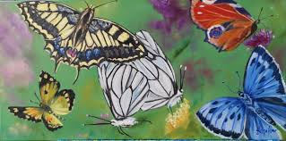
We plan weekly activities that encourage pupil’s independent learning skills. These reflect learning from the previous week. When the children have completed these tasks, they move their ‘butterfly’ through the life cycle to the ‘flourishing butterfly’ at the top and gain five monster points! These points gathered on Class Dojo go towards House points. These are Earth, Fire, Water and Air.

Thank you for taking the time to read this. You can find more information on our school website: http://www.stmaryswrithlington.co.uk/ or on our Facebook page: facebook.com/StMarysWrithlington/
If you have any further questions, please contact the school and someone will be happy to help!

