Be the best you can be
‘Whatever you do, work at it with all your heart’

Welcome to Summer Term 1, we hope you all had a lovely Easter!

Topic
The topic for Summer Term 1 is Superheroes. We have fans of Spiderman and The Incredible Hulk in our class, so there is no better topic! We have chosen to link this topic to the ‘superpowers’ insects and some animals have, so we will also be learning about minibeasts! 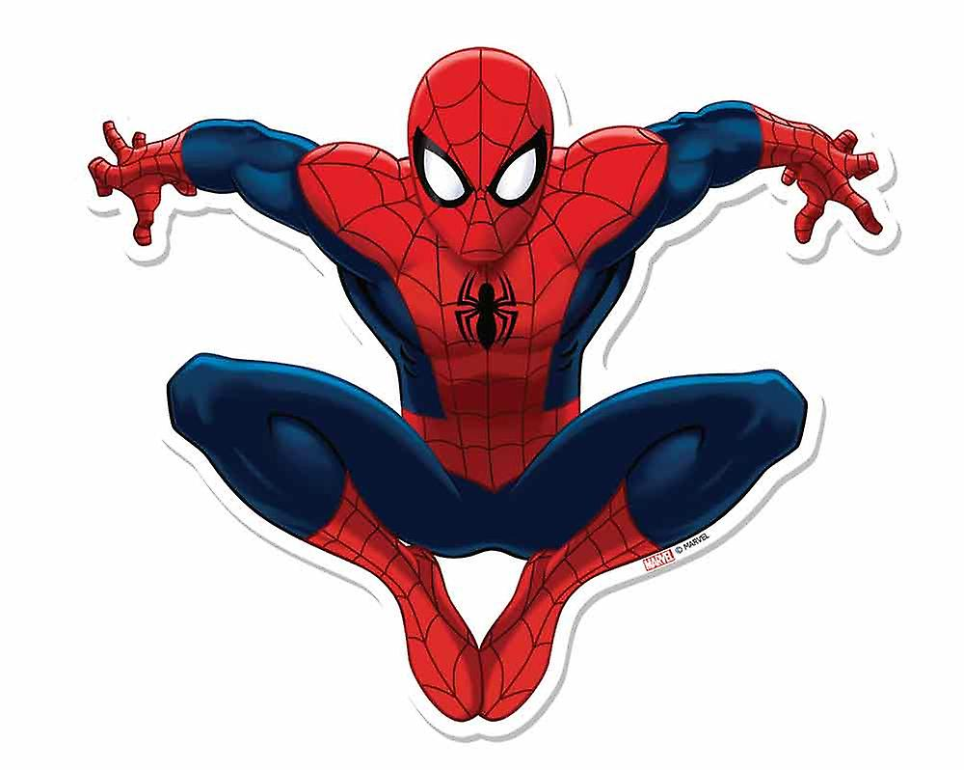

Reading
We have adjusted the systems in class this term, and your child’s ‘reading day’ has adjusted slightly (so don’t be concerned if your child’s books are no longer being changed on a Monday!). We listen to every child read on a 1:1 basis at least once each week. The children will continue to bring home a Reading for Pleasure book too. This is for you to read to and with them, perhaps at bedtime, simply to enjoy spending time sharing a fabulous book. We also support children with their key words, so please continue to practise these at home and ensure their reading books, reading records and sound books are in book bags every day. Don’t forget to practise the sounds we are learning in class in the sound books too!

PE is on Wednesdays and Thursdays this term, so please ensure your child comes in their kit on these days please!
Our Christian Value this term is:
Generosity and Service

Phonics
In phonics this term, we are continuing to revise the digraphs and trigraphs we taught during school closures. We are amazed at how much the children remembered from our Zoom lessons (thank you for your support with home learning – you really were all amazing!). After all the letter sounds have been taught (there are only a few left!), we will spend time consolidating so that children are really secure with blending (reading) and segmenting (spelling). There will be lots of fun activities to support with reading and writing sentences so children become more confident and fluent writers.

Literacy
This term we will be using our Writing superpowers-

We will be writing more captions using the Phonics
sounds we know and some tricky words.

We will also be writing sentences and answering questions about our superhero stories…
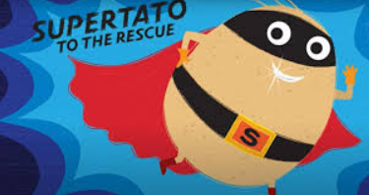
We will also be writing about our own SuperPowers…
What Superhero can we be?
What is our special super power?
Non Fiction writing will include finding out about some of the creatures that inspired our favourite Superheroes- Bats and Spiders!
Mathematics
The KIRF (Key Instant Recall Fact) for this term is: to count up to 100 in 10s. We have already begun to teach this, and we refer to these numbers (20, 30, 40, 50, 60, 70. 80 and 90) as ‘tea-drinking’ numbers – not to be confused with the ‘teen’ numbers! Children have already begun to spot patterns when using a 100 square to help count in 10s – wow! In White Rose Maths, we are extending our knowledge and understanding of numbers to 20 and beyond. There will be lots of fun maths games to support with this. We will also spend time learning about capacity and how much/many different sized and shaped containers can hold. We will also be revisiting 2D shapes.
Each week, we are continuing to support children 1:1 on their individual maths ‘learning steps’. We have moved this to a Monday (instead of Friday). Each child will work with an adult on their target and receive personalised support to ensure they achieve these targets quickly and securely. These are shared with you in the reading record – please support with these at home too!

KAPOW!

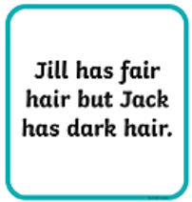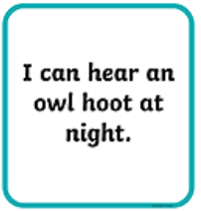

Like these…

What would Supertato do?

Foundation Subjects
We will be using Superheroes as inspiration for a number of really fun activities this term! You will soon see our spider hats (based on Spiderman), and we are learning about different minibeasts, we have even created a minibeast investigation area. The children have been enjoying exploring this area with magnifying glasses. We will be using the class IPad to take photos of each other and using these photos to turn the children into superheroes. We will add these to our class display board and upload a picture to Tapestry-Make sure you check it out! We will be learning about what plants need to grow by creating our own ‘Incredible Hulk Cress Heads’ and by watering the allotment which the PTA have kindly revamped for us. Towards the end of term, we are certain that the class superhero toys will be captured by some baddies (Dr Evil Iceman, I believe) and will need to be saved by the children in the class – let’s hope they know how to melt ice rapidly to help them escape – who knows what will happen if they can’t save the day!

And finally…
Your children have come back after the holidays ready to learn– it has made us very proud of them and all they have achieved throughout the last few, difficult months. They really are Little Oaks Superheroes!
Another huge thank you to all of you for your continued support and for the hard work you put in at home and in class.

Thank you,
The Little Oaks Team ☺

P.S. Please do have another look at home in case you have any of our Reading Scheme or Reading for Pleasure books that need to be returned. Many Thanks.

